Teaching Dossier

Benjamin Chapin
Ph.D. Candidate
Accounting Department | School of Business
Virginia Commonwealth University

chapinbe@vcu.edu

Contents

Part 1: Statement of Personal Teaching Philosophy 2
Part 2: Summary of Teaching Effectiveness 3
Attached: Full course evaluations 3
Part 3: Select examples of teaching materials 4

Part 1: Statement of Personal Teaching Philosophy

Teaching Motivation and Objectives
Classroom experiences have a lasting impact. I distinctly remember the excitement I felt in my undergraduate accounting information systems class because the instructor aligned the coursework with my career aspirations. That exciting feeling was a persistent influence on my 14 years as an industry accountant and inspired many of my best professional achievements. As an instructor, I strive to create a memorable classroom experience with objectives informed by research on motivation and feedback: (1) Foster domain-expertise; (2) Promote autonomy and efficacy; and (3) Connect students meaningfully with the material.

Overview of Teaching Experience
I have enjoyed teaching opportunities in applied courses where students practice using data analysis for accounting-based decisions in complex business environments. I first bridged classroom and practice in 2018 as a guest lecturer at Virginia Tech's Myers-Lawson School of Construction. The topic was on choosing business plan financials for securing investors in the construction industry. At VCU, I've taught two sections of Data Analytics for Accountants, where students use critical thinking with accounting information and tools like Excel, SQL, Power BI, Tableau, Alteryx, and Knime. My experience as a controller and CFO provides relevant industry insights. I want to use that insight to give students opportunities to build confidence while applying knowledge, facilitating connections between stakeholder objectives and data analytic frameworks using accounting information.

Critical Thinking, Motivation, and Feedback
I foster an environment that encourages critical thinking for deeper understanding. I pose questions frequently to guide students toward class objectives while promoting ownership of the learning experience. Self-directed discussions help students develop connections with the material, consistent with literature on autonomy and self-efficacy for intrinsic motivation. A former student noted: "I immediately reassure [others] that they are in good hands [referring to instructor] ... especially the importance of learning how to critically think." My research informs my feedback approach. I provide task-focused, self-referenced, and constructive feedback, identifying specific next steps for improvement.

Teaching and Learning Augmented through Technology
I leverage my AI research to inform instruction and pedagogy. I co-authored "Suggestions for the use of artificial intelligence tools in Ph.D. programs" and presented at the American Accounting Association's Conference on Teaching and Learning Excellence. I view AI tools as extensions of traditional tools that meet practice demands while exciting and inspiring students. Technology is both a design choice and a consequence of my teaching approach. A former student remarked: "Professor Chapin is the first professor I've had who truly shows that he cares about our success in class and out of college" and "He would allow us to choose from different software depending on our career requirements and would learn each one to grade assignments." In this way, my teaching experience has provided opportunities to apply my practical teaching goals of motivation, feedback, and the use of technology to meet those ends.

Part 2: Summary of Teaching Effectiveness
The table below summarizes my teaching evaluations to provide evidence of teaching effectiveness. All ratings are on a 5-point scale.

Class: Data Analytics for Accountants | Number of Students: 19
Term: Fall 2024 | Modality: In-person
Evaluation Description | Mean Rating
I feel the professor challenged and motivated me to learn. | 4.75
I see how someone can apply what was taught in this course to solve problems or challenges. | 4.88
The professor gave examples that helped me understand and/or apply the concepts that I was expected to learn. | 4.63
The professor gave assignments that helped me understand and/or apply the concepts that I was expected to learn. | 4.50
The professor used class time effectively. | 4.38
The professor created an atmosphere that encouraged class discussion and the expression of diverse viewpoints. | 4.63
When I requested assistance, the professor was helpful outside of class. | 4.75
I received timely feedback on class assignments and exams. | 4.38
I received useful feedback on class assignments and exams. | 4.75
Overall, how would you rate this instructor's teaching effectiveness? | 4.50

Attached: Full course evaluations

Part 3: Select examples of teaching materials

Class Exercise: beans.xls

Beans is a classroom-directed activity. The work happens during class time. The class uses a single dataset (beans.xls) and works through the process together, following along on their own machines. The exercise takes place over 3-4 class periods.
Note: This exercise is used with permission by Guido Geerts and Gail Hoover King, who presented this series of lectures at the 2024 Intensive Data Analytics Conference in Atlanta, GA.

The exercise follows the following framework:
The class proceeds through 20 ETL patterns in PowerBI that teach best data preparation practices through actual data manipulation. The data issue, detection, and correction procedures are highlighted for each pattern.

Starting with pattern 1, the student extracts data from the very large dataset (beans.xls) into Power Query…

Each pattern then methodically addresses three questions:
- What is the data issue?
- How is the issue detected?
- How do you correct the issue?
For example, Pattern 14 requires the identification of Invalid Values with Intra-Table rules. This means that values that invalid based upon the content of other values within a table.
In the beans.xls file, we want to make sure that the employees with a certain title received an appropriate rate for their services. The students use simple IF statements in DAX to return a simple Yes or No response in the RATEVALID column.
This issue is detected with the use of validation columns that we insert into the tables themselves. The students use simple IF statements in DAX to return a simple Yes or No response in the RATEVALID column.

The last question addresses the proper action to correct the issue. Several employees’ rates are not correct. We identify those employees and ask for management guidance. In this case, there is no manipulation taken without additional information. This reinforces data integrity and control.
At the end of each class, we save the .pbix file and pick up with changes made.
By the end of 3-4 class periods the data set has been completely processed and is ready for further analysis.
The step-by-step nature reinforces the ETL process as a heuristic, where data patterns are expected, and the student becomes proficient at identifying data exceptions in an efficient manner.

Homework Exercise: Chapter 7 – Jumpers

Question stem:
“Explore with an Interactive Report Jumpers is a grocery store in Indianapolis with locations in NIndy (North Indy) and SIndy (South Indy). They compiled a five-year report with revenues generated for each of their seven product categories (meat, drinks, vegetables and fruits, snacks, freezer, diary, other).”
- Create an interactive report based on the following exploration structure.
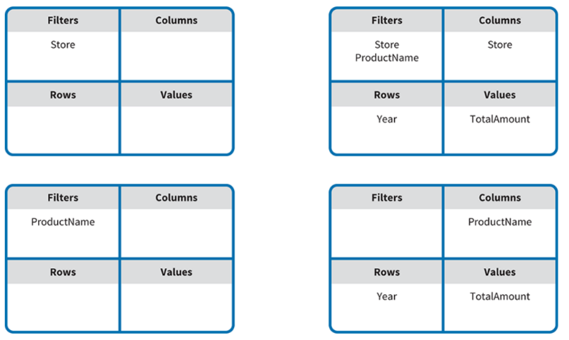
The student is given a small data set in Excel.
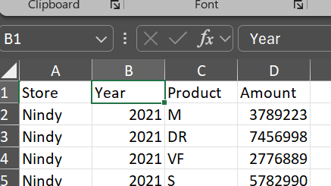
The data is spread across several worksheets, requiring relationships to be mapped in Tableau.


The student sets up the appropriate relationship in Tableau.
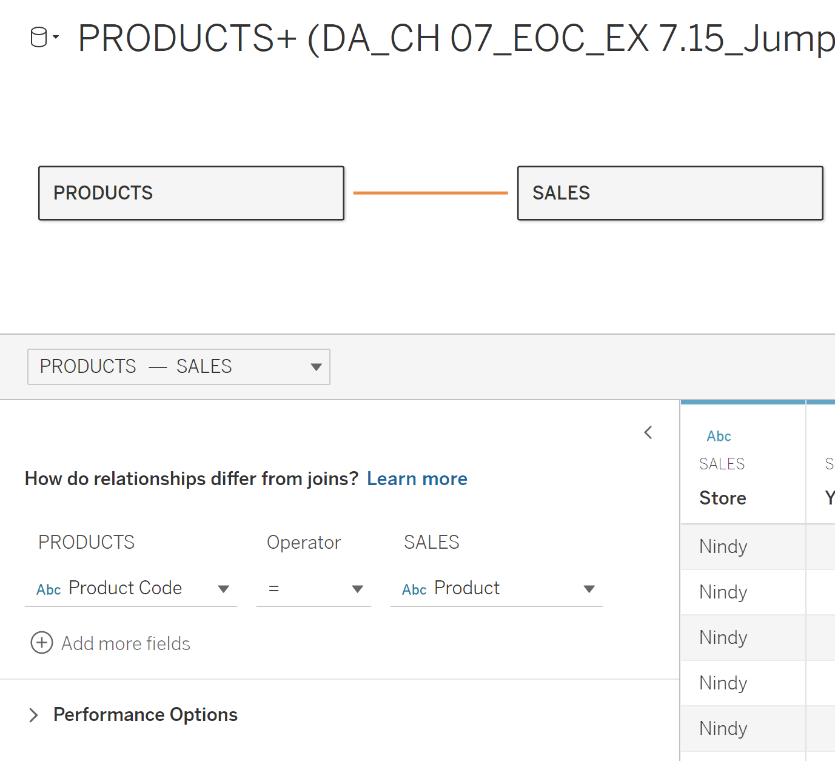
The student uses Tableau to create a series of visualizations using the information model.
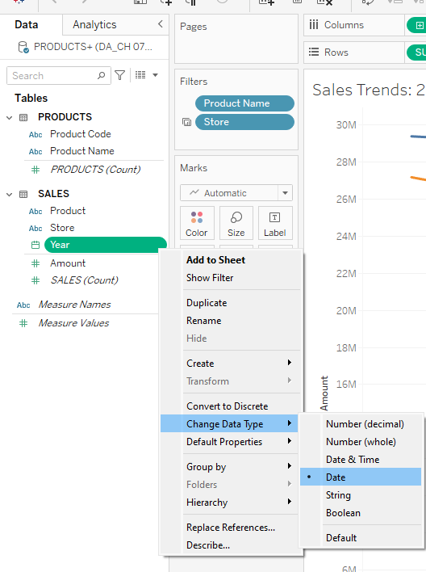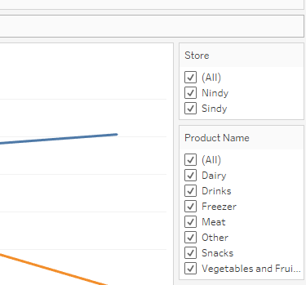

The resulting dashboard is fully interactive and will look like this:
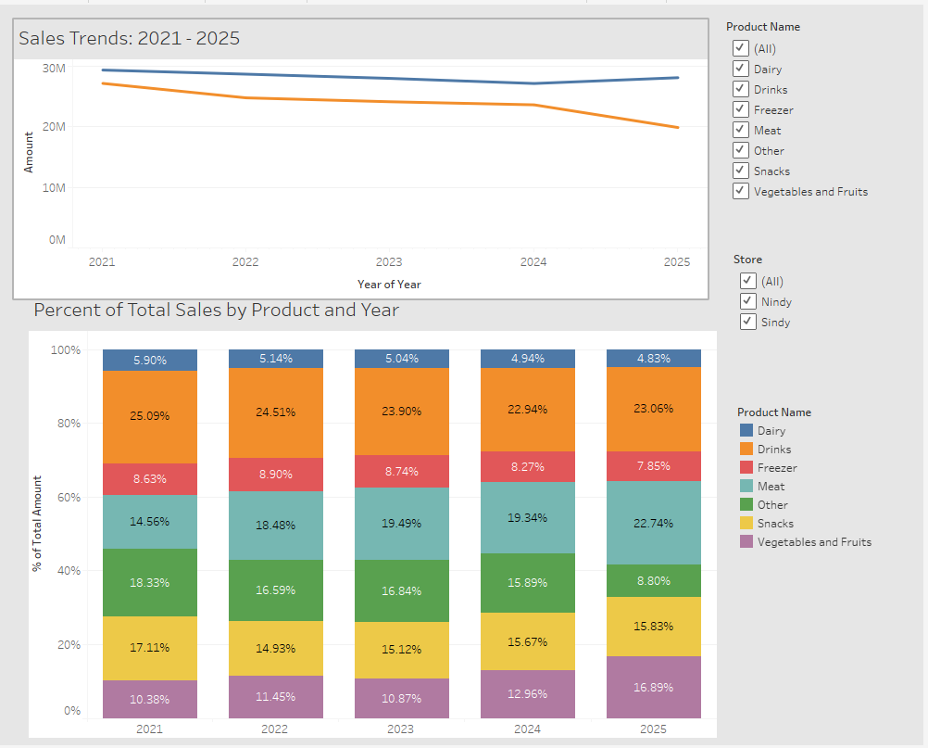

- Describe the relationships that are part of your dashboard
Question 2 answers come from the information model. The relationships and visualization type follow a series of patterns introduced to practice analysis, insight, and communication best practices.
  - The Store and Product slicers are filters, not visualizations of data relationships.
  - The line chart represents a time series: How have revenues changed during the 2021-2025 period for both stores?
  - The 100% stacked column chart helps explore changes (time series) in the contribution of each of the different product categories (part-to-whole) to revenue (composite trend).

- Identify questions that can be explored with your dashboard.
Question 3 answers use a “Jeopardy” logic – the student identifies questions that may be addressed using the visualizations.

  - How do the revenue trends for the two stores compare?
  - How do the revenue trends for “Vegetable and Fruits” products for the two stores compare?
  - What product category generated most revenue in 2025?
  - What product category generated most revenue in 2025 for the SINDY store?
  - What product categories have become increasingly more important in generating revenue?

Project 2: Bene Petit

Bene Petit: An Integrated Analytics Case

Stacey Whitecotton
Arizona State University

Case Overview

This case describes an entrepreneurial venture that has both a business and social mission. The case setting is a hypothetical meal delivery service that utilizes a “one-for-one” business model in which the owner pledges to donate one meal for every meal sold. The case storyline is modeled after Bombas®, which was featured on Shark Tank and is one of the show’s biggest success stories.2
The case is suitable for an undergraduate or MBA managerial accounting course; and could also be used in a cross-functional introductory business or entrepreneurship course. The case is designed to run throughout the entire course and includes various assignments that faculty can discuss in class, assign as homework, or use as individual or team projects.

Objectives of the case include:
• Increase students’ appreciation for the role of managerial accounting in an entrepreneurial business.
• Illustrate the importance of social responsibility and sustainability in modern business strategy.
• Apply managerial accounting topics to a simple but non-traditional setting than blends manufacturing and service.
• Require students to integrate course concepts and methods to make data-driven decisions.
• Enhance students’ analytical skills through Excel- and Tableau-based projects and assignments.

The case covers the early stages of the business’s life cycle, including concept/beta-testing, start-up/introduction, and expansion/growth. It is divided into five parts:
• Part 1: Understanding the Business
• Part 2: Product and Service Costing
• Part 3: Managerial Decision Making
• Part 4: Budgetary Planning and Control
• Part 5: Performance Evaluation and Analysis

Each part includes discussion questions, assignments, and Excel or Tableau based projects.

